Name: Karina Petrenko
Student Number: 20118132
Course: Software System Development
Group:W1
I plan to include the following pages on my website:
- Home Page
- About Me
- Gallery
- Contact page
The overall color scheme will mainly feature pastel colors in shades of lavender and lilac with bright accents.
Style - I would like to create a website about myself and my hobby with a modern look, but without losing tenderness and femininity.
Font - I plan to mainly use the Roboto font because I find it clear and easy to read, which fits in quite well with the concept of my website.
Colors that will be used
Main background | #faf5ff
Main text | #4b296b
H1 | #9333ea
H2 | #7e22ce
Nav background | #da66d4
Footer background | Image
Contact Form background | #c939d6

Wireframe for the Main Page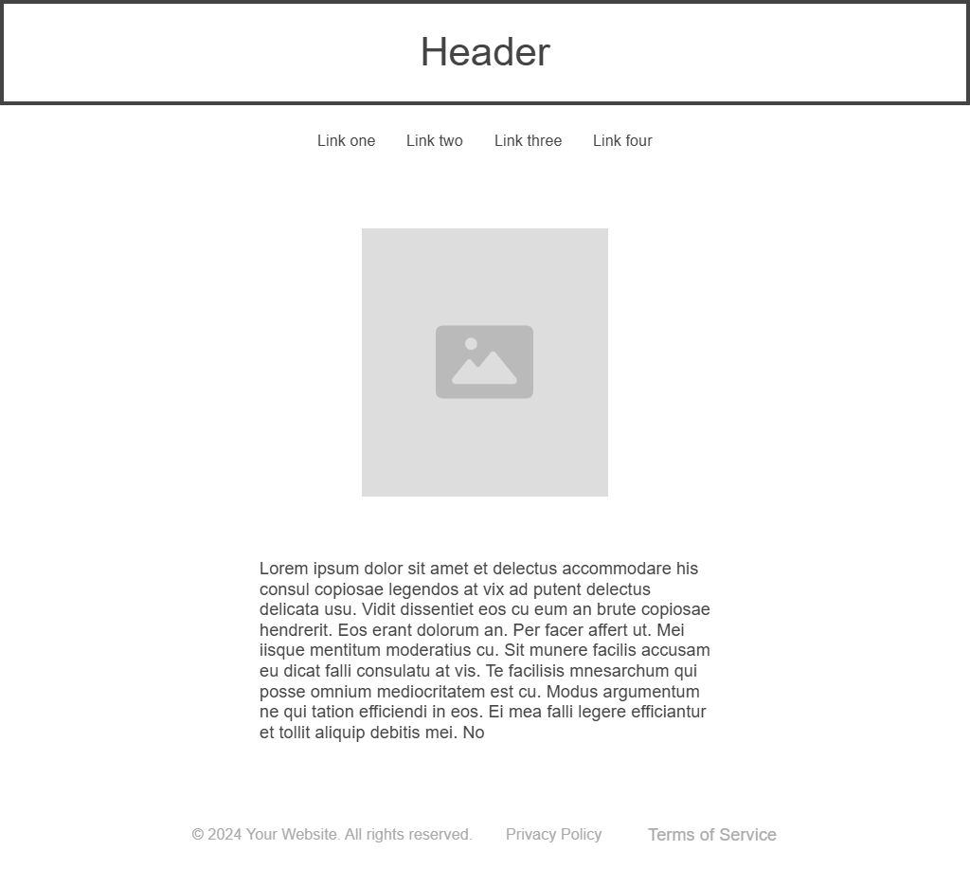
This image shows the structure of the Home page. It includes a header, navigation bar, my photo, brief information about the content of the entire site, and a footer.
I plan to make the photo round because I think it will look more appropriate that way.
The navigation bar will be placed horizontally, immediately below the header.
The footer will be located at the bottom of the page, with a background image and text.

Wireframe for the About Me page
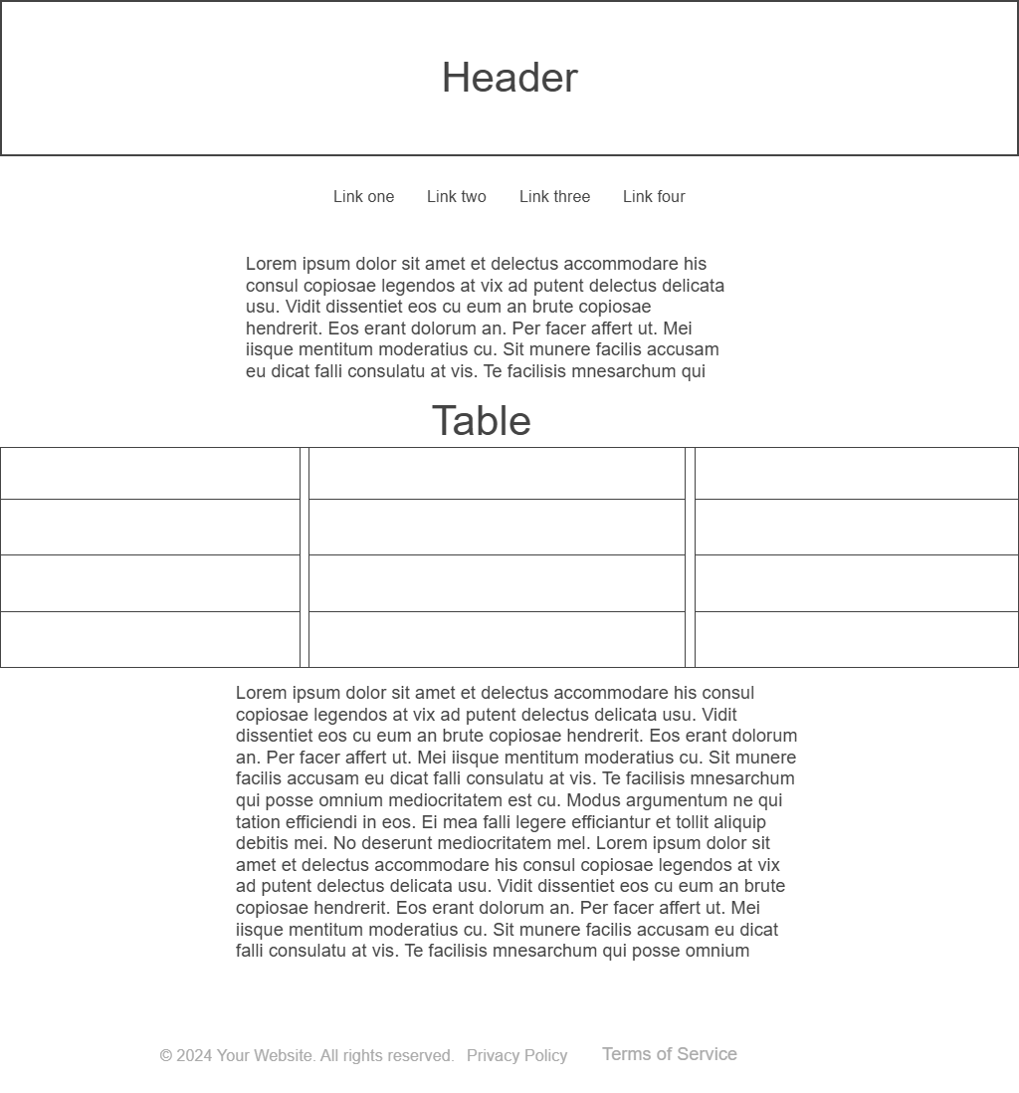
This image shows the structure of the About Me page. It includes a header, navigation bar, several paragraphs of text about me, a footer, and a table with information and embedded external links.
The navigation bar will be placed horizontally, immediately below the header.
The table will be placed in the middle of the text. External embedded links will open in a new tab.
The footer will be located at the bottom of the page, with a background image and text.
Wireframe for the Gallery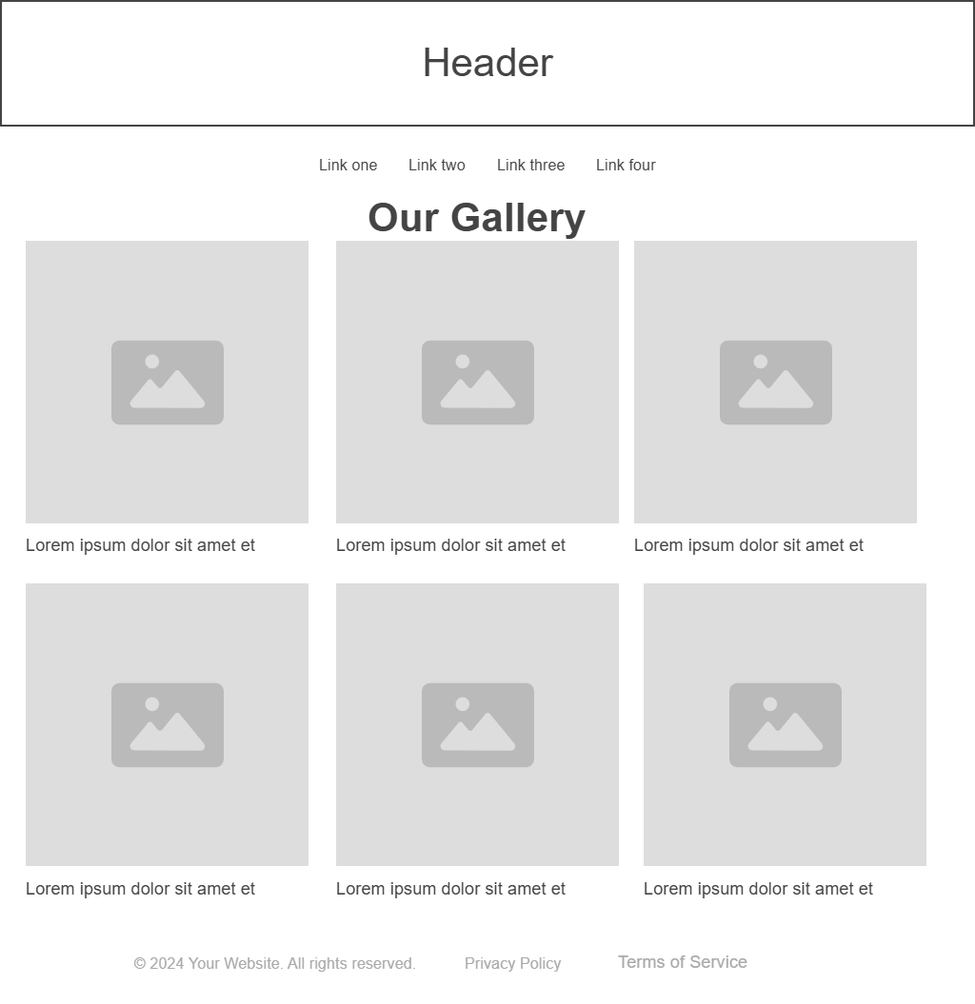
This image shows the structure of the My Gallery page. It includes a header, navigation bar, footer, and several photos with captions.
The photos will be arranged in rows of three, with a caption under each one.
The navigation bar will be positioned horizontally, immediately below the header.
The footer will be located at the bottom of the page, with a background image and text.

Wireframe for the Contact Page
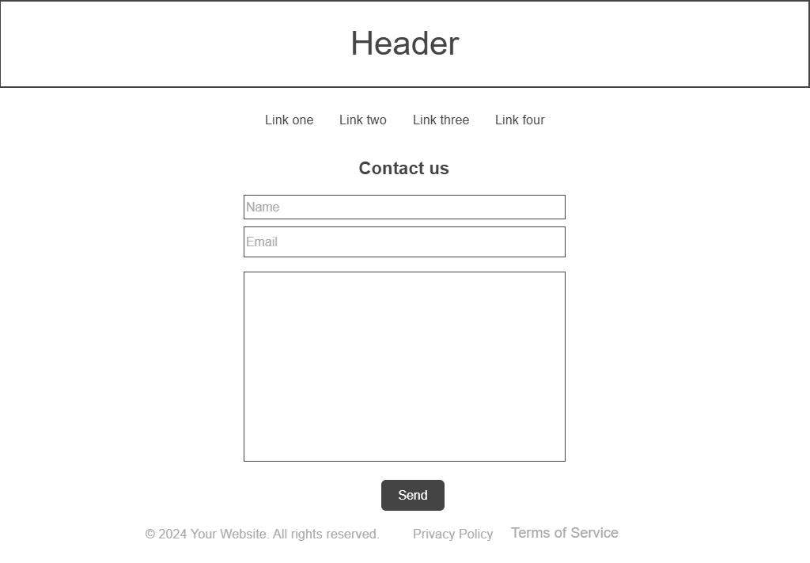
This image shows the structure of the Contact page. It includes a header, navigation bar, footer, and contact form for feedback.
The navigation bar will be placed horizontally, immediately below the header.
The contact form will include fields for the user's name, email, and message, as well as a button to send the entered information.
The footer will be located at the bottom of the page, with a background image and text.

